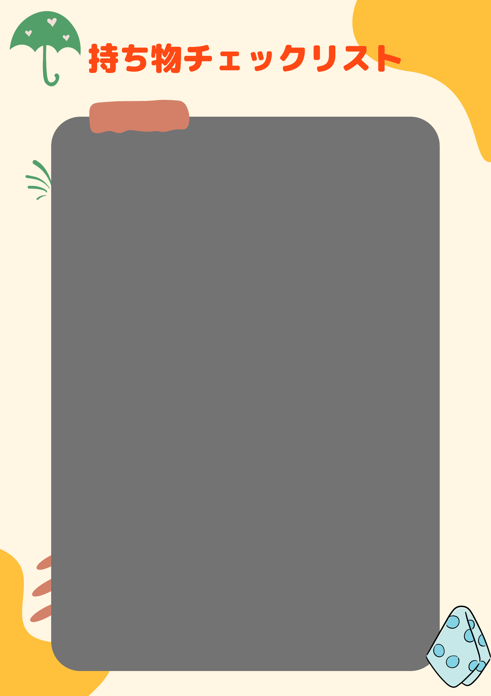

日間

|  |  |
| --- | --- |
| チェック | 持ち物 |
|  |  |
|  |  |
|  |  |
|  |  |
|  |  |
|  |  |
|  |  |
|  |  |
|  |  |
|  |  |
|  |  |
|  |  |
|  |  |
|  |  |
|  |  |
|  |  |