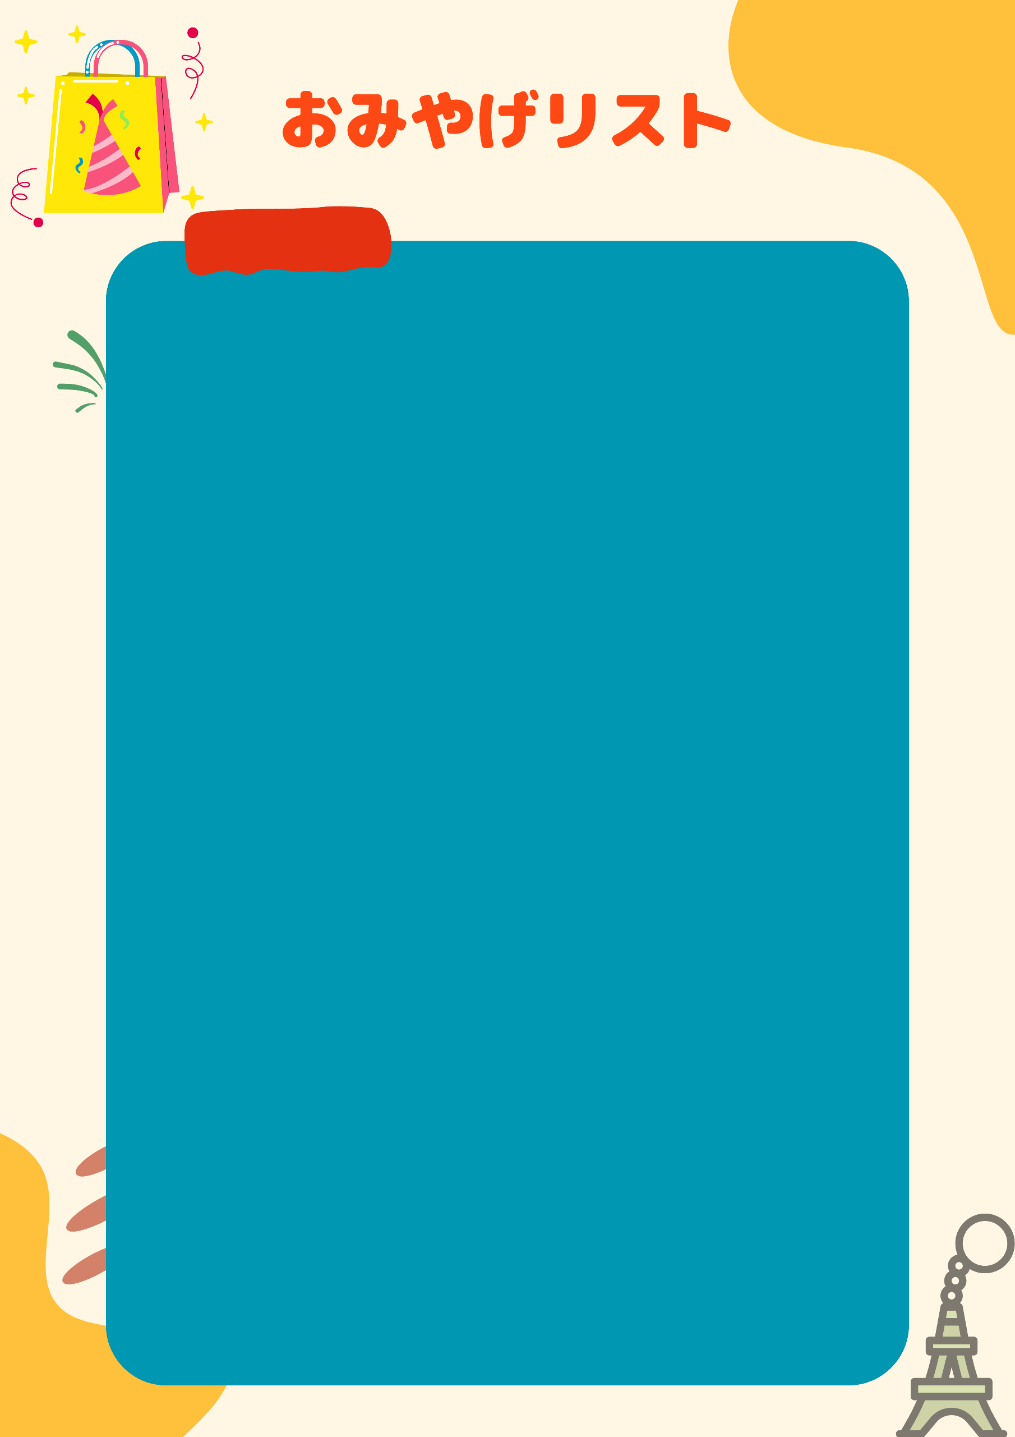

家族・会社

|  |  |  |
| --- | --- | --- |
| チェック | 相手 | おみやげ |
|  |  |  |
|  |  |  |
|  |  |  |
|  |  |  |
|  |  |  |
|  |  |  |
|  |  |  |
|  |  |  |
|  |  |  |
|  |  |  |
|  |  |  |
|  |  |  |
|  |  |  |
|  |  |  |
|  |  |  |
|  |  |  |